Foreign Language Week Poster Contest
Posters due: Tuesday, February 28, 2017
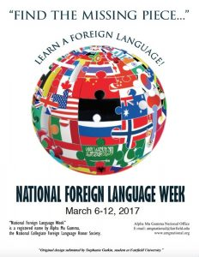
- Receive up to 10 Points extra credit.
- Grade winner will be exempt from a quiz.
- Must have the theme on the poster.

Foreign Language Week Songs
Songs due: Tuesday, February 28, 2017
- Find a song that came out in 2016 or 2017 in your language.
- Must include title and artist.
- Receive 1 point extra credit.

