Je m’appelle - ____________________________________________ French 6
La date - ________________________________________________ L’école

Directions: Look at the picture below. On the lines provided, write the appropriate classroom object. Be sure to include the article!

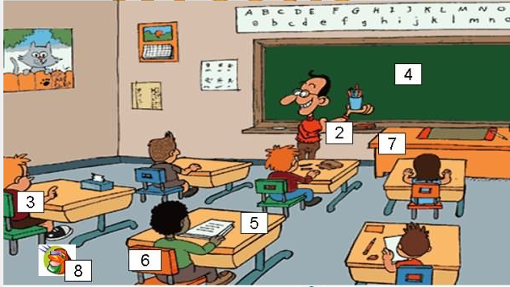
1

- __________________________________________
- __________________________________________
- __________________________________________
- __________________________________________
- __________________________________________
- __________________________________________
- __________________________________________
- __________________________________________

