Je m’appelle - _______________________________________ French 6
La date - ___________________________________________ Le Vocabulaire

Les Parties Du Corps
Le corps - ____________________________
La tête - _____________________________
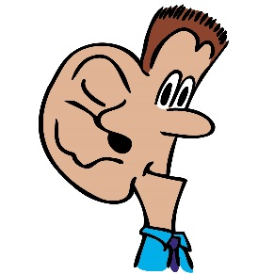
Le visage - ____________________________
Le front - ______________________________
Les cheveux- __________________________
Les yeux (l’oeil) - ____________________________
Le nez - ____________________________
La bouche - ____________________________
Les dents - ____________________________
Les lèvres - ____________________________
Le menton - _____________________________
L’oreille - ____________________________
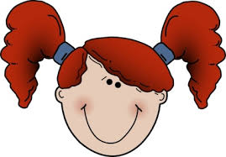
La gorge - ____________________________
La langue - ____________________________
Le cou - ____________________________
L’estomac/ Le ventre - ____________________________
Le dos - ____________________________
Le bras - ____________________________
La main - ____________________________
Le doigt - ____________________________
Le pouce - ____________________________
L’ongle - ____________________________
Le coude - ___________________________
La jambe - ____________________________
Le genou - ____________________________
Les épaules - ____________________________
Les pieds - ____________________________
Les doigts à pied - ____________________________
Le coeur - ____________________________

Expressions & Answers
Avoir + mal - _____________________________________________________________
Où as-tu mal? - _____________________________________________________________
J’ai mal au/à la/aux - _________________________________________________________
Je suis malade - _____________________________________________________________
Je suis fatigué (e) - __________________________________________________________

